**Week 4 Hands-On: CompTIA Roadmap: IT Support Specialist and Cybersecurity Specialist**

You may answer all questions by taking and pasting your screenshots.

1. Go to: [https://www.comptia.org/content/it-careers-path-roadmap](https://www.comptia.org/content/it-careers-path-roadmap/)
2. Click on ‘IT Support Specialist’ (as shown below inside the blue box)  
     
     
   
3. What is the median salary for a Beginner, IT Support Specialist? (2 pts)  
     
   The median salary for a Beginner IT Support Specialist is $34,220 to 49,770
4. At the bottom of the page, what are the first two certifications shown for the IT Support Specialist? (5 pts)   
     
   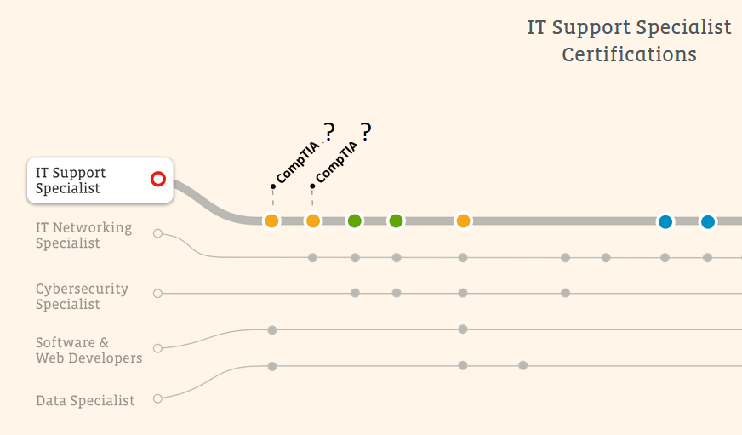

Answer: Certification #1:CompTIA ITF+

Certification #2:CompTIA A+

1. Using the answers from question #4, what are the CMPR courses offered at Santa Ana College that will prepare you for these two certifications? (HINT: there should be three courses and exam vouchers are provided free after successful completion)  
   View the webpage: <https://sac.edu/it> to help you find the answer (9 pts)  
     
   Course #1:CMPR 125: IT Help Desk Fundamentals  
   Course #2:CMPR 153: A+ Essentials Hardware

Course #3:CMPR 155: A+ Essentials Software

1. Name the first SAC certificate that you can earn with these three courses along with three more courses. (total of six courses) (3 pts)  
   (HINT: review the Computer Information Systems brochure from <https://sac.edu/it>)
2. Go to: [https://www.comptia.org/content/it-careers-path-roadmap](https://www.comptia.org/content/it-careers-path-roadmap/)

Click on ‘Cybersecurity Specialist’ (as shown below inside the blue box)  
  
  


1. What is the median salary of a beginner Cybersecurity Specialist? (2 pts)
2. What are the two certifications for the beginner Cybersecurity Specialist? (5 pts)

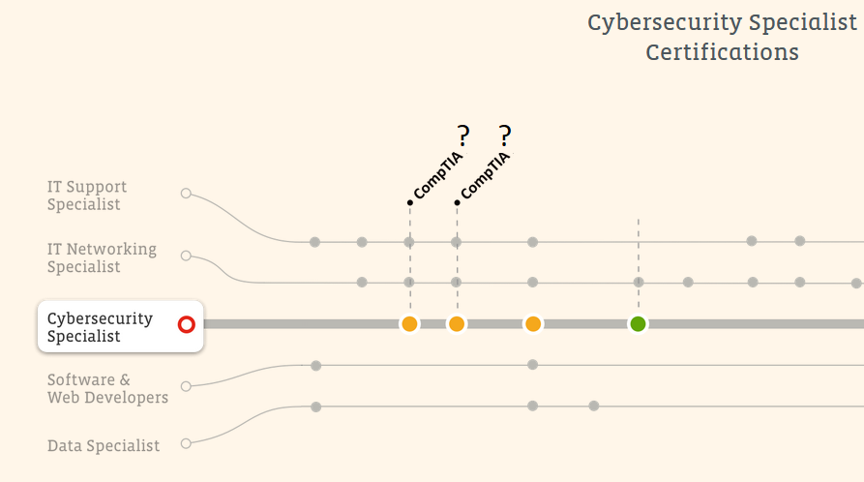

1. Using the answers from question #9, what are the two CMPR courses offered at Santa Ana College that will prepare you for these two certifications  
   View the webpage: <https://sac.edu/it> to help you find the answer (6 pts)

Course #1:  
Course #2:

1. Go to <https://indeed.com> and search for ‘it support specialist’

1. How many jobs are available for ‘it support specialist’? Take a screenshot. (2 pts)
2. Now do an Indeed search for ‘cybersecurity’. How many cybersecurity jobs are available? Take a screenshot. (2 pts)
3. Do you still plan to stay on the SAC IT Cybersecurity Pathway? What courses will you take next and when? If you learned that IT Cybersecurity is not for you, tell me some reasons why. If you have more questions, message me on Canvas. (4 pts.)

*Best wishes to you and your future endeavors!!!*

END